To create a random paragraph we type =rand(5,5)where first 5 is number of paragraph and second 5 is number of lines in a paragraph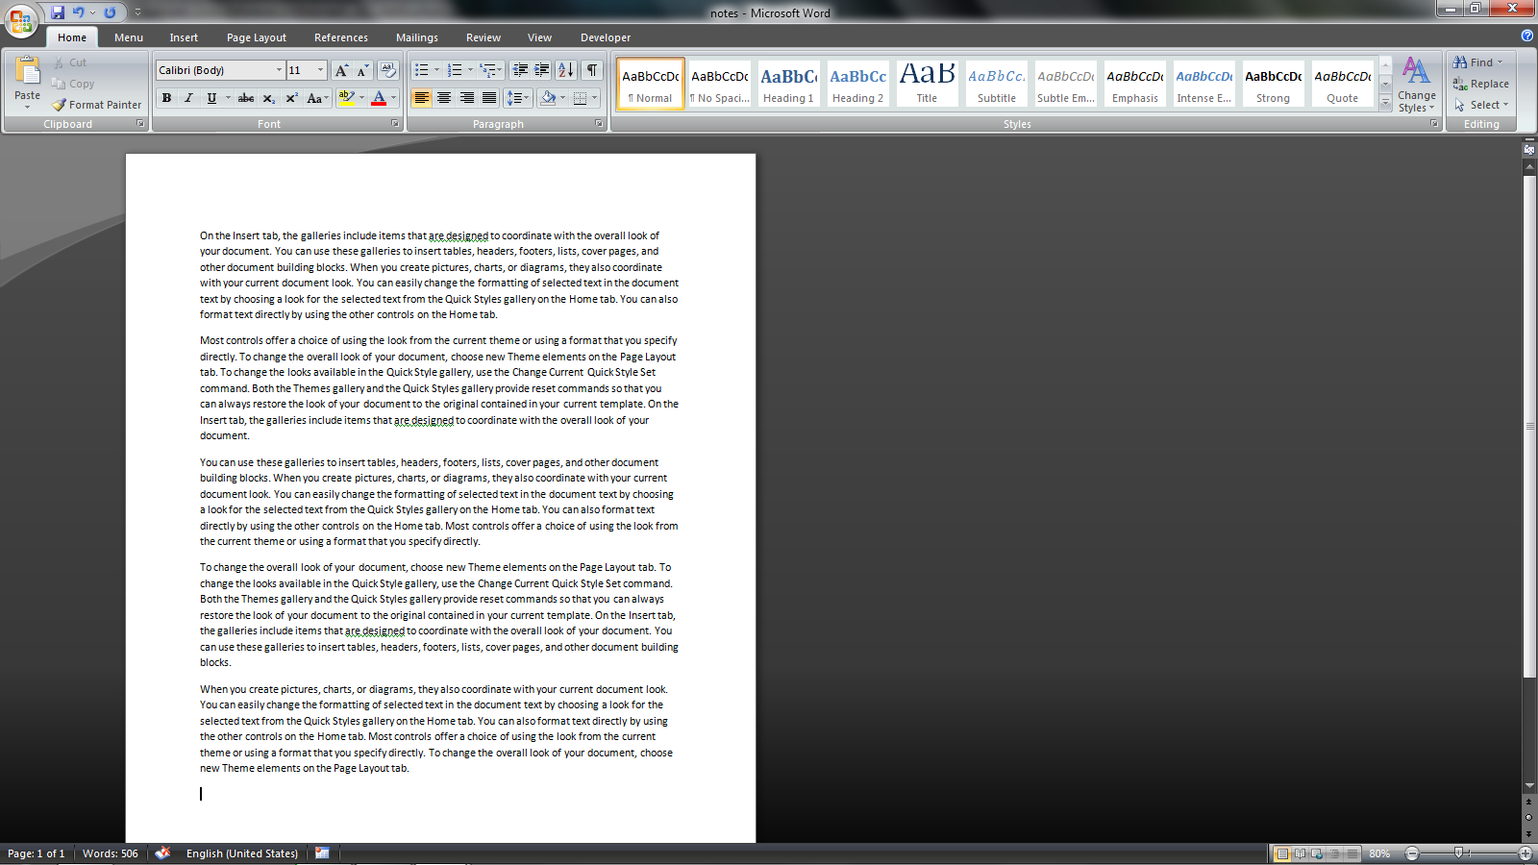

Create hyperlink – can be done on own
Convert some text to heading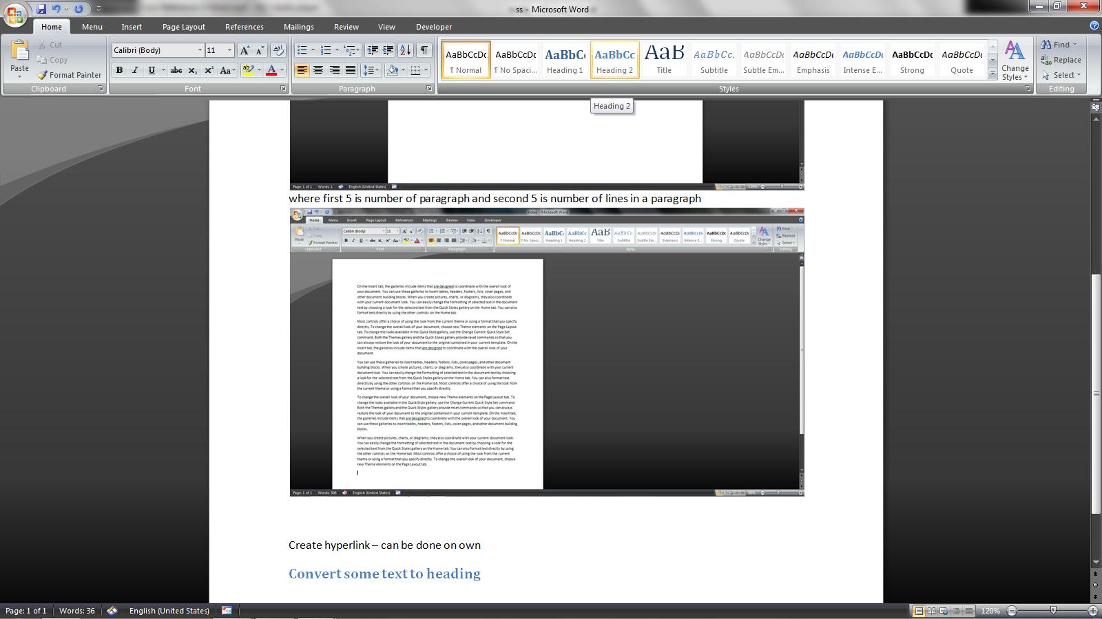to use more features of hyperlink
And also use bookmark for the same

Cross reference is similar to hyperlink but only works with same file and can do more things than hyperlink
- Bullets can’t be counted during cross reference, we have to use numbers to that
- Image can be hyperlinked only if caption was added to that image

